**Project Deliverable 3**

**Grading Rubric:**

|  |  |  |  |  |  |
| --- | --- | --- | --- | --- | --- |
| **Criteria** | **%** | **25%** | **50%** | **75%** | **100%** |
| **Use of Machines** | **20%** | There is no clear usage of machines or is missing | The machines exist but does not adequately preview the structure of the layout | The machines show the main flow and previews the structure of the design | The machines are present clearly, shows the main design and previews the structure of the layout |
| **Design of Layout** | **20%** | There is no clear Design of the layout | The design states the main idea but does not adequately preview the structure of the layout | The design shows the main idea and previews the structure of the layout | The design is engaging, states the main topic and previews the structure of the layout |
| **Flow** | **20%** | No evidence of structure or flow organization | Each resource lacks supporting infrastructure | Each flow has sufficient supporting infrastructure that develop the process | Each resource has thoughtful supporting details that develop the whole process |
| **Process Explanation** | **20%** | There is no clear explanation of the process | Vaguely states the explanation of the process | Clearly states the explanation of the process | Engaging, & states the purpose of project and its approach and potential results |
| **E Learning Certificate (Individual)** | **20%** | Student need to submit the E-Learning Course Completion Certificate |  |  |  |
|  |  |  |  |  |  |

**The project**

Introduction:

A company named KMD (Kuwait Motor Design) is investing in a new production hall for their company. KMD is producing 2 types of electrical gear motor:

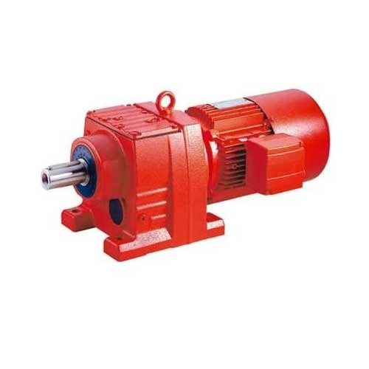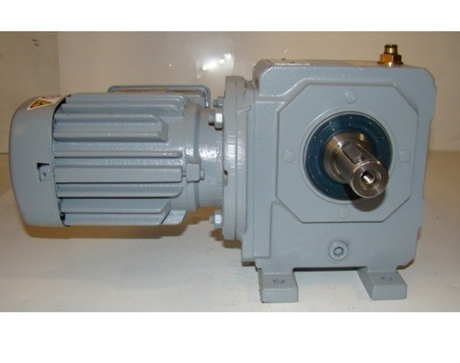

*The KMD Inline Motor*

*The KMD Bevel Motor*

KMD management would like to create 2 new production line in this production hall:

* 1x production line for the KMD Bevel Motor
* 1x production line for the KMD Inline Motor

Product Structure diagram:

The product diagram of the Bevel Motor is as followed:

Bevel Motor

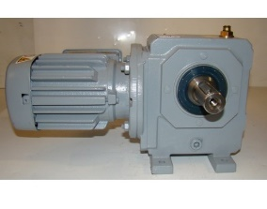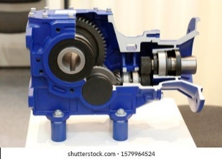

Gearbox A (1)

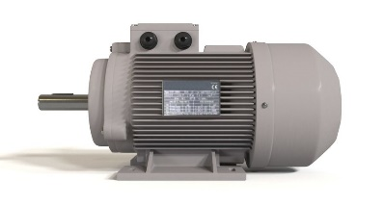

Electrical motor (1)

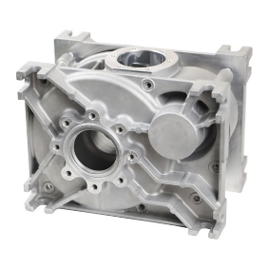

Aluminum housing (1)

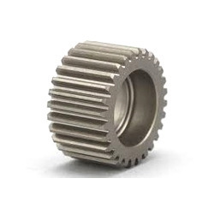

Gear (4)

Inline Motor

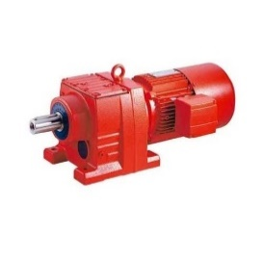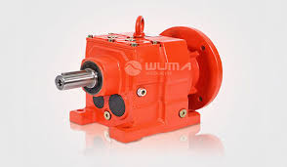

Gearbox B (1)



Electrical motor (1)



Aluminum housing (1)



Gear (2)

The different machines:

*1 – CNC Lathe Machine:*

The CNC Lathe is a machine tool used to produce **the Gears**, cycle time is specified on Product structure diagram. **A worker must operate this machine full time.**

For the maintenance of this machine, the access of **the back must be open at least 2 meters.**

**Produce 3 Gears per hour.**

To run, this machine requires **5 m3/h of pressurized air and 68 kWatts.**

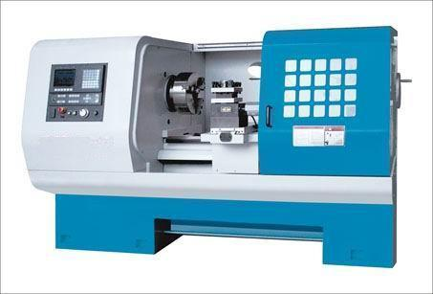

*2 – Aluminum casting cell:*

The Aluminum casting cell is a group of machines operated by a robot in the middle. It will produce the **Aluminum Housing**, cycle time is specified on Product structure diagram. **It doesn’t need a full time operator**, one worker can come **half of his time**.

A safety zone around this cell must be applied, any worker in this zone must be wearing protection glasses, gloves and ears protection. **This zone must be a circle of 10 meters diameter around the casting cell.**

**Produce 2 Aluminum housing per hour.**

To run, this machine requires **20 m3/h of pressurized air and 25 kWatts.**

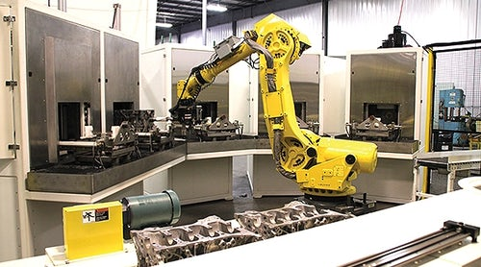

*3 – Gearbox Assembly line:*

The Gearbox assembly line is a line used to **assemble the Gears and Aluminum housing together**. It is operated by **2 worker at the same time.** It can **assemble Gearbox A and Gearbox B.**

It requires a lot of calm and clear lighting for a work of precision. For this reason it must be as far as possible from the Aluminum casting cell.

**Produce 2 gearboxes per hour.**

To run, this line requires **15 m3/h of pressurized air and no electricity.**

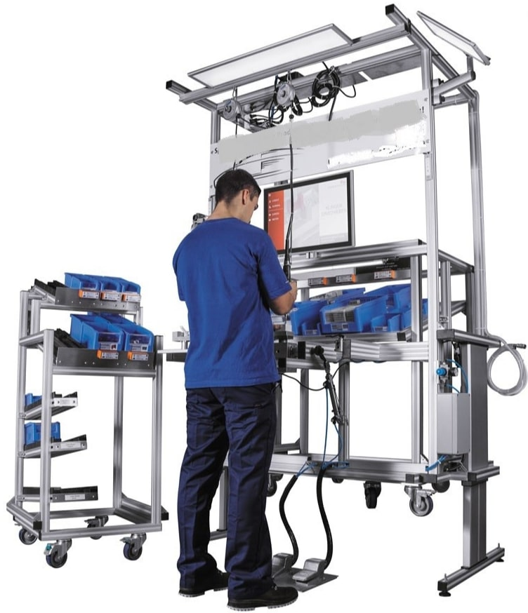

*4 – Electrical motor cell:*

The Electrical motor cell is a group of machines operated by a robot in the middle. It will produce the **Electrical motor**, cycle time is specified on Product structure diagram. **It doesn’t need a full time operator**, one worker can come **half of his time*.***

**Produce 1 motor per hour.**

To run, this machine requires **20 m3/h of pressurized air and 25 kWatts.**

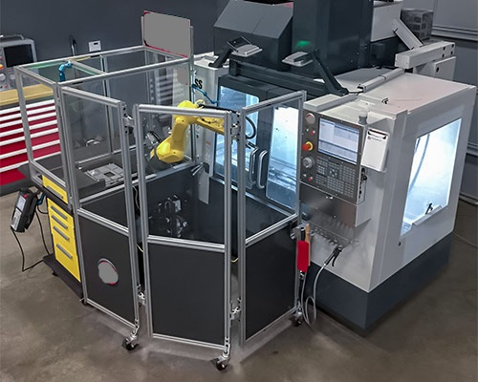

*5 – Final assembly line:*

The Final assembly line is a line that will **assemble the Gearbox and the Electrical motor together**.

It can assemble **only one type of Motor (Bevel or Inline)**. This means that **we need 2 Final assembly lines**: One for the Bevel motor and one for the Inline motor.

**Each Final assembly line will need one worker.**

**Produce 1 assembly per hour.**

To run, this line requires **15 m3/h of pressurized air and no electricity.**

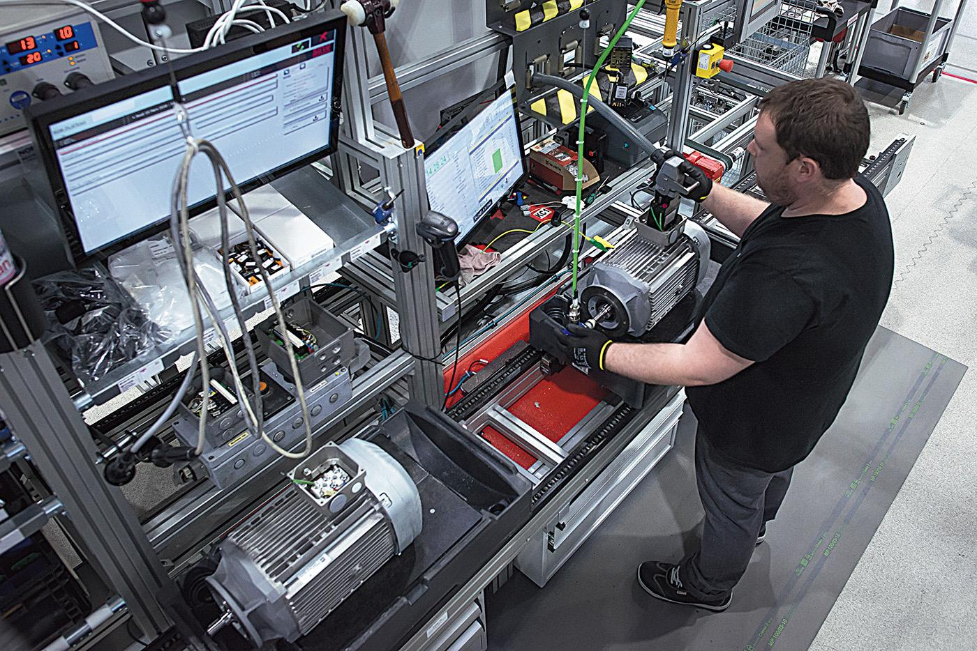

*6 – Jib crane:*

The Jib crane is a lifting equipment. It is used to move heavy loads.

A jib crane is needed **next to the CNC Lathe machines.**

To run, this equipment requires **no pressurized air and 10kWatts.**

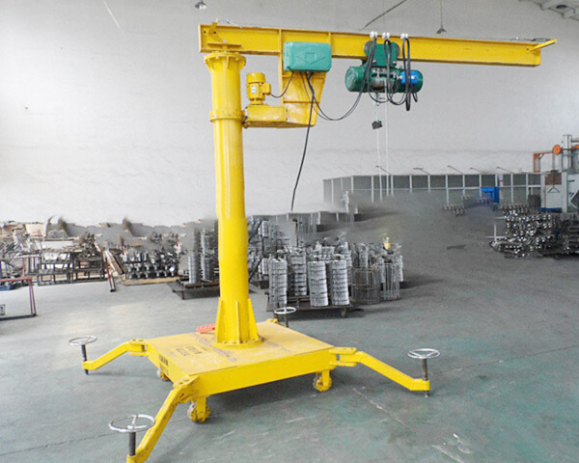

Read carefully the specifications below:

* 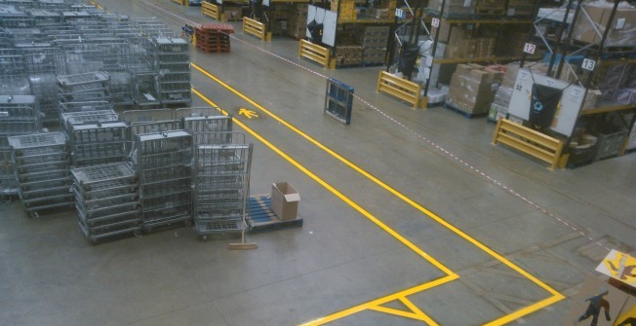The minimum size for a walkway is 1.2 meters (Safety standards).
* The minimum size for a forklift aisle is 4 meters (Safety standards).

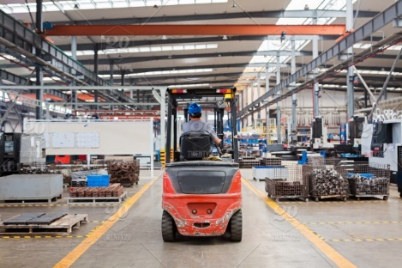

* A surface of 6m2 must be considered for the recycling of industrial waste like cartons, plastics, metal (Environmental standards).



* 4x Fire extinguishers must be placed in the factory in strategic places (Safety standards).

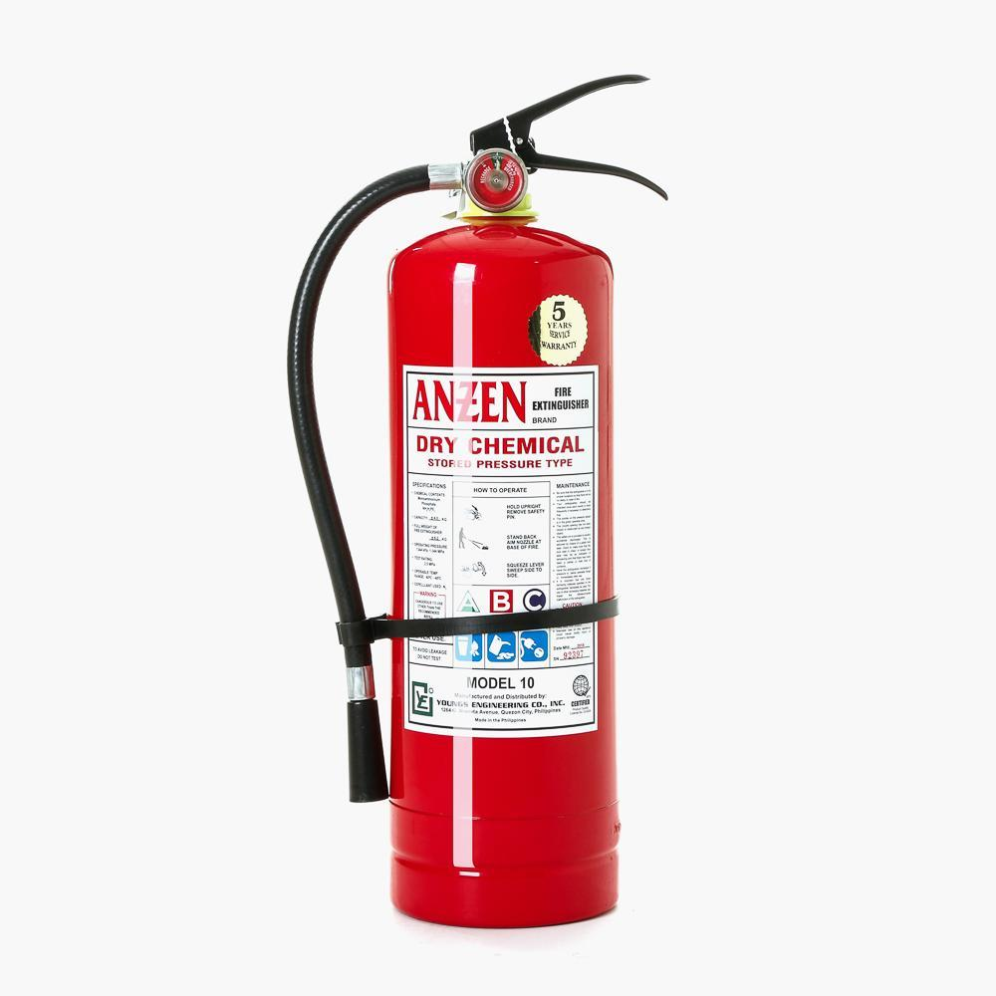

*Steel column (cannot be moved)*

*4 meters*

Layout of the facility

WC

Changing room

Management office

Electric motor cell

Gearbox assembly line

Aluminum casting

CNC Lathe

Final assembly

Layout of the machines

Jib Crane



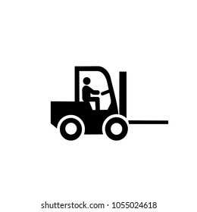

What you have to do:

From the previous page (p.15), copy and paste the machines on the layout of the facility (p.14). Create all the symbols that you need. Design a facility that can produce the Bevel motor and the Inline motor. Be sure to respect all the specifications given before.

**If you need, you can duplicate the machines.**

Examples of what you can present:

* Show the flow of product in your facility, from the first machine to the last.
* Show how many employees you need in your facility.
* Explain why you position the machines this way.
* Show the forklift aisles and walkway.
* Show the electrical power and pressurized air needed at each point of the facility.
* Any information that you consider interesting.